“I have a dream that my four little children will one day live in a nation where they will not be judged by the color of their skin, but by the content of their character.”

- Martin Luther King, Jr.

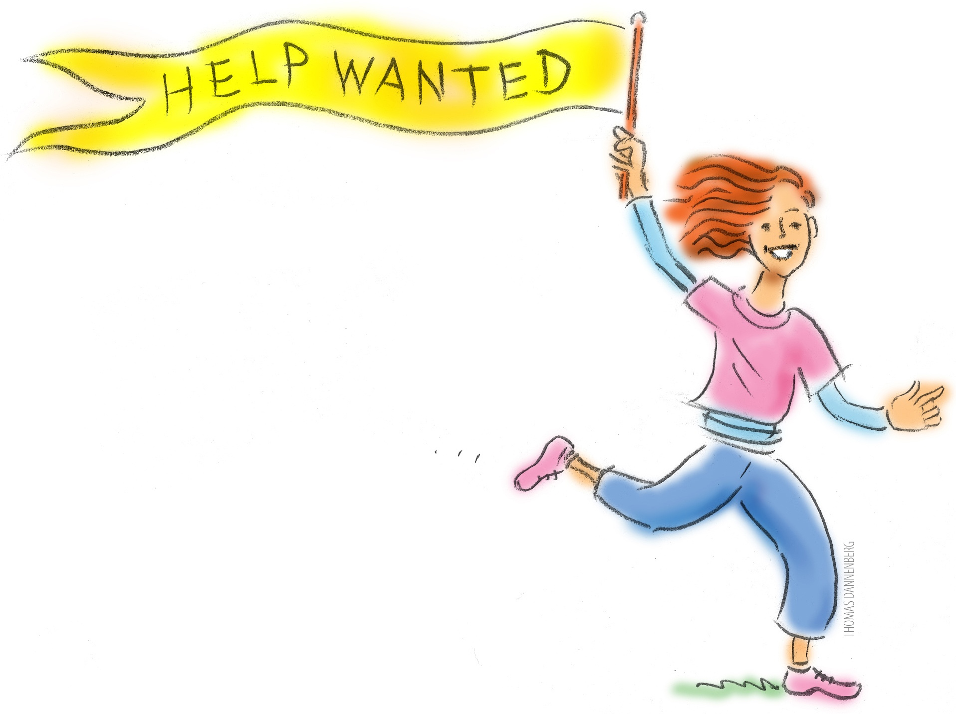

Classroom volunteers are needed to help with this program! Volunteers teach a simple monthly lesson reinforcing different character traits. Typical lessons involve reading a story, playing a game, or sorting cards. Lesson plans and most materials are supplied; you choose the grade-appropriate lesson that you feel most comfortable teaching.

Help us create a partnership of parents, teachers, administrators, and children working together to develop good citizens.

For more information, come to orientation Wednesday, September 21st at 8:00 a.m. in the Miramar Ranch Multi Purpose Room or e-mail character.education@yahoo.com. All are welcome.

